Salesforce Development Bridge – Day 1 Documentation
Name: Gayathri Ettela
Scenario: Hospital OPD Management System
Date: 28 July 2026

Task 1 – Data Model Design
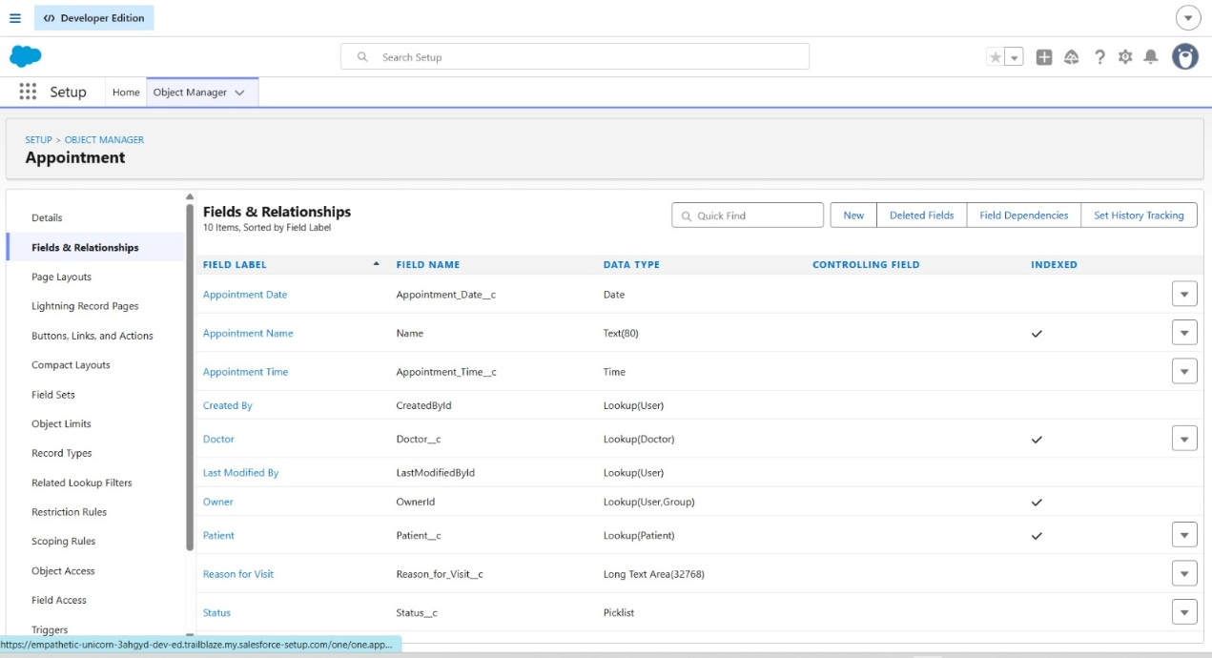

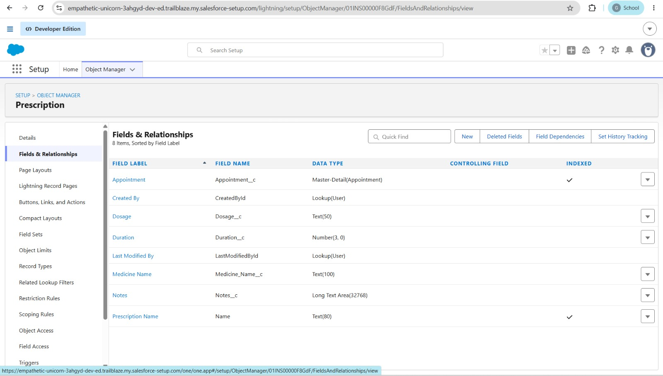

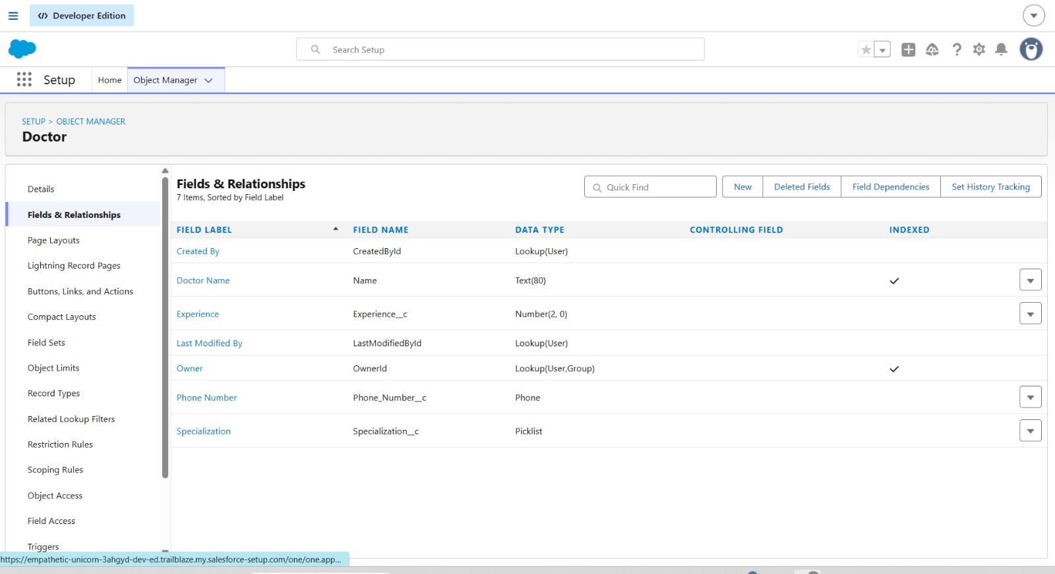

Task 2 – Apex Basics
Trailhead Module Completed
- Apex Basics & Database
Activities Performed
- Learned the fundamentals of Apex programming language.
- Practiced variables, data types, operators, and control statements.
- Created and executed Apex code using Execute Anonymous in the Developer Console.
- Learned how to use System.debug() and analyze Debug Logs.
- Practiced writing and executing SOQL queries.
- Retrieved records from Salesforce objects using SOQL.
- Understood how Apex interacts with Salesforce data through sObjects.
Sample Apex Code Executed
Integer num = 10;
String message = 'Hello Salesforce';
System.debug(num);
System.debug(message);
Result
The code executed successfully in Execute Anonymous, and the expected output was displayed in the Debug Log.
Key Concepts Learned
- Apex Classes
- Variables and Data Types
- Methods
- System.debug()
- SOQL Queries
- sObjects
- Developer Console
- Debug Logs
- Task 3 – SOQL Practice
- Query 1 – WHERE Clause
- SELECT Name, Age__c
- FROM Patient__c
- WHERE Age__c > 30
- Output
- Total Rows: 0

- Query 2 – ORDER BY + LIMIT
- SELECT Name
- FROM Patient__c
- ORDER BY CreatedDate DESC
- LIMIT 5
- Output
- Patient-0001
- Patient-0002
- Patient-0003

- Total Rows: 3

- Query 3 – Relationship Query
- SELECT Name,
- Patient__r.Name,
- Doctor__r.Name
- FROM Appointment__c
- Output
- Appointment-0001 | John | Dr. Smith
- Appointment-0002 | Mary | Dr. Rao

- Total Rows: 2

- Query 4 – Aggregate Query
- SELECT COUNT(Id)
- FROM Appointment__c
- Output
- expr0
- 2

- Query 5 – Comparison Operator (>=)
- SELECT Name, Age__c
- FROM Patient__c
- WHERE Age__c >= 18
- Output
- John | 25
- Mary | 32

- Total Rows: 2

Task 4 – Apex Trigger
Trigger
Create Apex Trigger → AppointmentTrigger
trigger AppointmentTrigger on Appointment__c (
before insert,
after update
) {

if(Trigger.isBefore && Trigger.isInsert){
AppointmentTriggerHandler.beforeInsert(Trigger.new);
}

if(Trigger.isAfter && Trigger.isUpdate){
AppointmentTriggerHandler.afterUpdate(Trigger.new);
}
}

